**Linear Graphs GCSE Questions**

**Q1.** *y* = 5*x* − 4     is the equation of a straight line.

(a)     Write down the gradient of the line     *y* = 5*x* − 4

Answer ......................................................................

**(1)**

(b)     Write down the coordinates of the *y*-intercept of the line     *y* = 5*x* − 4

Answer     (.............................. , ..............................)

**(1)**

**(Total 2 marks)**

**Q2.**

A sketch of 2*x* + 3*y* = 12 is shown.

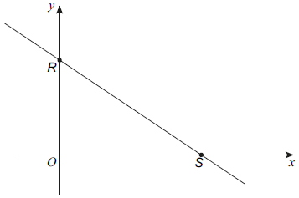

(a)     Work out the coordinates of *R*.

Answer (........................., .........................)

**(1)**

(b)     Work out the coordinates of *S*.

Answer (........................., .........................)

**(2)**

**(Total 3 marks)**

**Q3.**

(a) Write down the equation of a straight line that is parallel to *y* = 5*x* + 6

      ..............................................................................................................................................

**(1)**

(b) Find an equation of the line that is perpendicular to the line *y* = 5*x* + 6 and passes through the point (–2, 5).

      ..............................................................................................................................................

**(3)**

**(Total 4 marks)**

**Q4.** Lines, *A* and *B*, intersect on the *y*-axis.

Line *B* intersects the *x*-axis at the point (6, 0).

The equation of  line *A* is        4*x* + 3*y* + 12 = 0

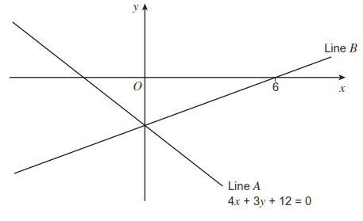

Work out the equation of line *B*.

Answer ......................................................................

**(Total 4 marks)**

**Q5.** The diagram shows a line *ABCD*.  
*A* is the point (400, 920).  
*B* is the point (250, 620).  
The line cuts the *y*-axis at *C* and the *x*-axis at *D*.

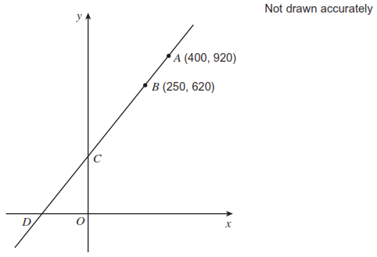

Work out the coordinates of *C* and *D.*

*C* ( ....................... , ....................... )

*D* ( ....................... , ....................... )

**(Total 4 marks)**

**Q6.** Two straight lines are shown.

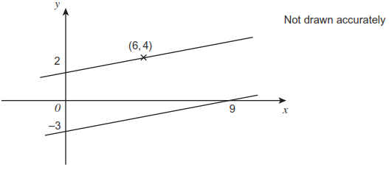

Prove that the lines never meet.

**(Total 3 marks)**

**Q7.**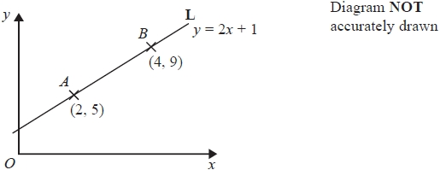

The point *A* has coordinates (2, 5).   
The point *B* has coordinates (4, 9).

The line **L** passes through the points *A* and *B*.   
The equation of line **L** is *y* = 2*x* + 1

*M* is the midpoint of the line segment *AB*.

Find an equation of the line that is perpendicular to line **L** and passes through *M*.

**(Total 4 marks)**

**\*Q8.** *A* is the point with coordinates (1, 3)   
*B* is the point with coordinates (4, −1)   
The straight line *L* goes through both *A* and *B*.

Is the line with equation 2*y* = 3*x* − 4 perpendicular to line *L*?   
You must show how you got your answer.

**(Total 4 marks)**

**Q9.**  
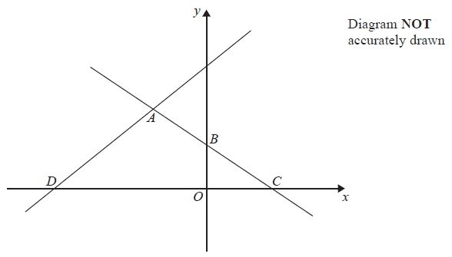

In the diagram, *ABC* is the line with equation $y=-\frac{1}{2}x+5$

*AB* = *BC*  
*D* is the point with coordinates (−13, 0)

Find an equation of the line through *A* and *D*.

**(Total 5 marks)**

  Answers

**M1.**(a)     5

**B1**

(b)     (0, −4)

**B1**

**[2]**

**M2.**

(a)     (0, 4)

**B1**

(b)     (6, 0)

**B2ft**

**[3]**

**M3.**

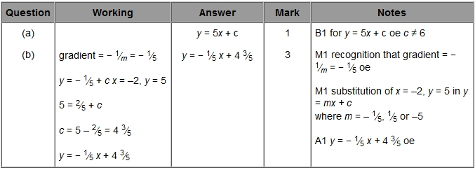

**M4.**          3*y* + 12 = 0

**M1**

*y* = −4

**A1**

Gradient = 

**M1**



*oe*

**A1 ft**

**[4]**

**M5.**          Gradient = 2  or  *y* = 2*x* + *c*

**M1**

Substituting *x* = 250,  *y* = 620  or  *x* = 400,  *y* = 920

**M1 dep**

*c* = 120  or  *C* = (0, 120)

**A1**

*D* = (−60, 0)

**A1**

**M6.**         Right-angled triangle drawn above or below either line, with lengths indicatedorEither 2 and 6  or  3 and 9 used as a ratio or fraction

*Correct substitution into gradient formula   … or inverted*

*Award for   seen with no working*

**M1**

   and   

**A1**

Both simplify to    so lines parallel or have same gradient  
or

Equations are   and   hence lines are parallel or lines havesame gradient

**A1**

**[3]**

**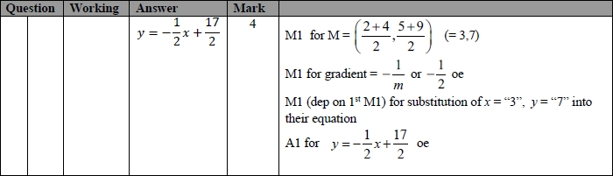 M7.**

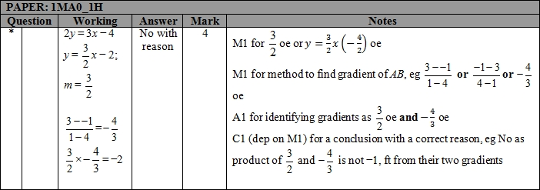**M8.**

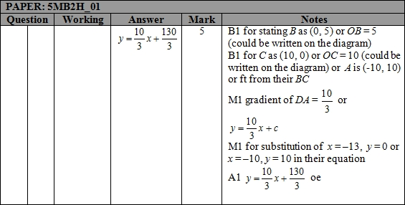

**M9.**